**Janron Consult Limited Profile**

Since 2020, Janron Consult, has been providing clients with personalised Customs Tax Advisory and Consultancy services in Nairobi, Kenya for the last 5 years. Janron Consult has developed into Janron Consult Limited as from May 2024. We advise clients on General Customs Procedures, Application of Customs Laws and Regulations, Valuation of Imported Goods, Import Goods Classification, Objections to Kenya Revenue Authority Opinions on Valuation and HS Classification of goods, Import and Export Procedures, Kenya Revenue Authority Audits, Import Duty, VAT, Excise Duty, Teaching Sessions on Customs Topics of Interest, Tax Planning by advice on Least Cost Import Procedures, Seek Exemptions from the Government.

Janron Consult Limited specialises in Customs Taxation. The lead consultant teaches HS Classification at KESRA. (KESRA) is the Kenya Revenue Authority’s premier training school specializing in Tax and Customs Administration, Fiscal Policy and Management. The school is one of the only four World Customs Organization (WCO) accredited Regional Training Centres (RTCs) in Eastern and Southern Africa.

**Experience in Taxation**

The lead consultant, Charles Mukangu, was trained at the Kenya School of Revenue Administration (KESRA) for 2 Years (2003 to 2005), in, Income Tax law, Value Added Tax, Road Transport Regulations and Customs Laws and Regulations. Thereafter he worked at the Customs and Border Control Department for 14 years. (2005-2019)  
 He worked in the field for eight years conducting physical verification of consignments, valuation of imports, online input of verification findings and scanning of exports, processing of inbound foreign passengers, risk analysis of incoming foreign passengers based on pre-determined profiles and intelligence.  
Six years was spent at the Document Processing Centre (DPC)at Times Towers. DPC is the nerve centre of all customs operations in the country. This is the office that processes, documentation for all customs entry and exit declarations, which includes, exports, imports, warehousing, transhipments, temporary imports, ex-warehouse imports, EPZ exports, transit goods, re-warehousing etc.  
At DPC the Declarations and supporting documents, submitted online, are analysed, for , accurate description, correct valuation as per market values, accurate commodity classification, adherence to Customs Laws and regulations and thereafter passed for onward verification and release in the field. That is approximately 140,000 different types of import/export documents handled/processed in six years.  
In the course of my stay at KRA, I worked with the Uganda Revenue Authority officers at Malaba Border station, certifying exit and entry of consignments in transit for the East African Community, partner states, which are Uganda, Rwanda, Congo, Burundi, South Sudan and Tanzania.

**16 YEARS CUSTOMS EXPERIENCE**

|  |  |  |
| --- | --- | --- |
| KENYA SCHOOL OF REVENUE ADMISTRATION | MOMBASA/NAIROBI  TAX TRAINING | 2003-2005 |
| DHL/TRANS GLOBAL | JOMO KENYATTA INTERNATIONAL AIRPORT | 2005-2007 |
| DOCUMENT PROCESSING CENTER | TIMES TOWERS, NAROBI | 2007-2009 |
| MOI INTERNATIONAL AIRPORT | MOMBASA | 2009-2012 |
| ONE STOP BORDER STOP | MALABA | 2012-2016 |
| DOCUMENT PROCESSING CENTER | TIMES TOWERS, NAROBI | 2016-2019 |
| CUSTOMS TAX CONSULTANT | NAIROBI | Mar 2020 to Date |
| LECTURER CUSTOMS  TAXATION KESRA | NAIROBI | May 2022 to Date |

**CUSTOMS TAX PARTNER/CUSTOMS TAX CONSULTANT FOR:**

(1) BASF EA LTD

(2) IMCD Kenya Limited

(3) REDACHEM EAST Africa Ltd

(4) Phillips Pharma Group

(5) Sharma Orthopaedics Africa Ltd

(6) Austell Pharmaceuticals (PTY) Ltd

(7) Modern Integrated Feeds Ltd

(8) Choice Nutrition Ltd

(9) Laborex Kenya Ltd

(10) Laxcon Hardware & Spares Ltd

(11) Premier Solar Solutions Ltd

(12) DryGro Kenya

(13) Wessex Pharmaceuticals Ltd

(14) Phillips Therapeutics Ltd

(15) Amiken Ltd

(16) Speedex Logistics Ltd

(17) Skylux Logistics Ltd

(18) Transonic Logistics

(19) Iris Port Conveyors (K) Ltd

(20) Land Bridge Freighters Ltd.

(21) Highlands Canners Limited

**Services offered by Janron Consult Limited**

1. Provide general customs tax advisory to clients. Conduct research and give expert advice to business, international organisations, consultants, industry, trade bodies, investors, start-ups, researchers, on customs procedures in Kenya.

2. Advice clients on import duty, value added tax, excise duty, import declaration fees, railway development levy {customs duties} for tax planning by providing guidance on the least cost import procedures

3. Provide teaching sessions on topics of interest in customs in Kenya

4. Managing interactions and customs dispute resolution on behalf of the client with Kenya Revenue Authority (KRA)

5. Represent, advice, guide, the client on Kenya Revenue Authority audits(customs)

6. Review of client’s customs transactions to introduce efficiency and savings

7. Customs laws and regulations, compliance checks

8. Advice clients on the most beneficial customs classification of imported goods

9. Application to KRA for advance rulings for valuation, HS classification of goods

10. Raise objections to KRA, on behalf of the client, for contested imported goods classification and valuation during clearance and resulting from post clearance audits

11. Obtain VAT exemptions from Ministry of Health for allowable imports

**OTHER DETAILS**

Cell phone +254708751955

Website: https://www.janronconsult.com/

Email : mcmukangu@janronconsult.com

LinkedIn: https://www.linkedin.com/in/charlesmukangu/

Work Done for Clients: https://www.janronconsult.com/category/clients-work-2022-case-studies/

**TAX TRAINING CERTIFICATION**

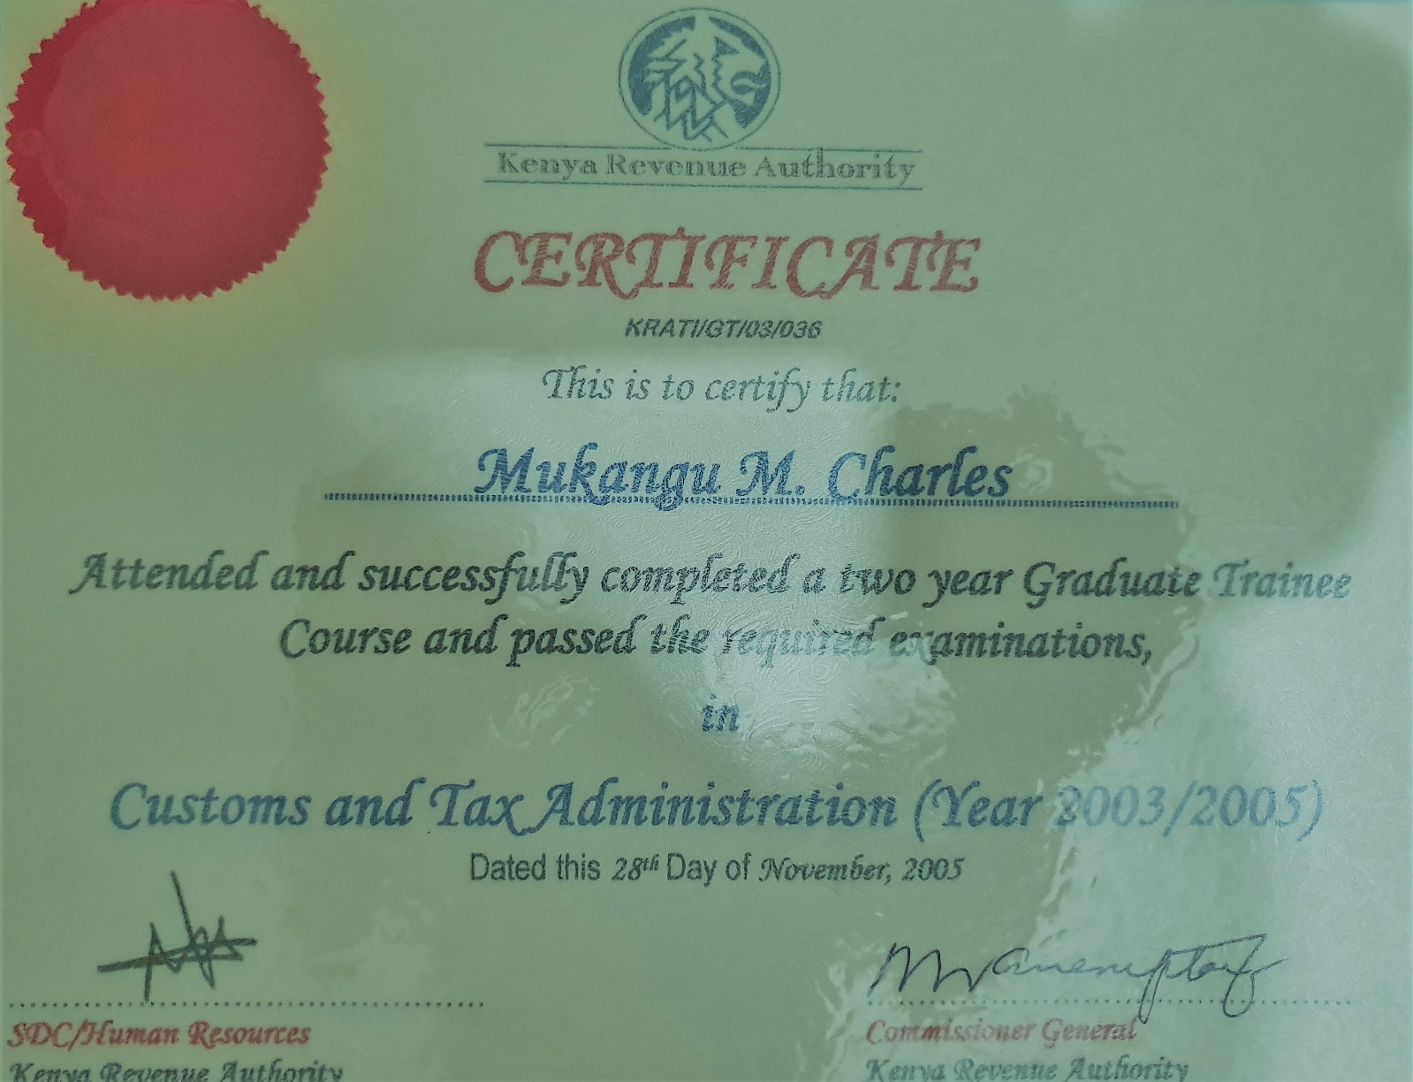

**Certificate of Company Registration(CR 12)**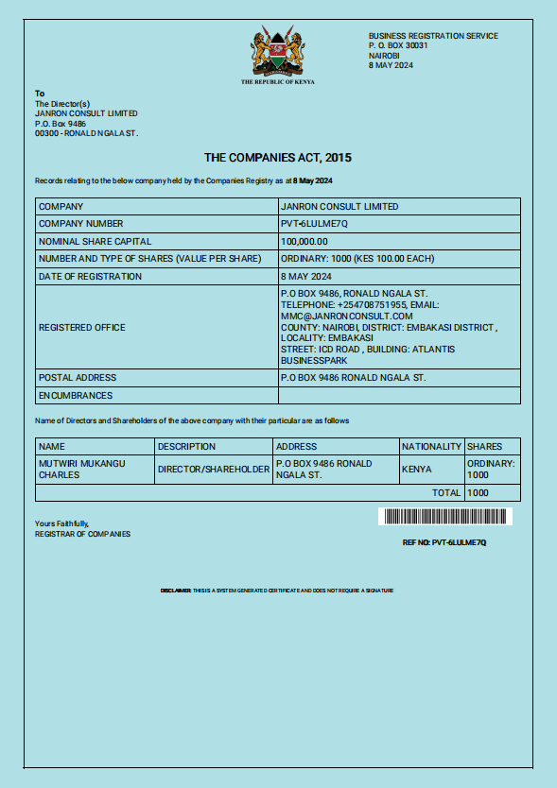

**Certificate of Incorporation**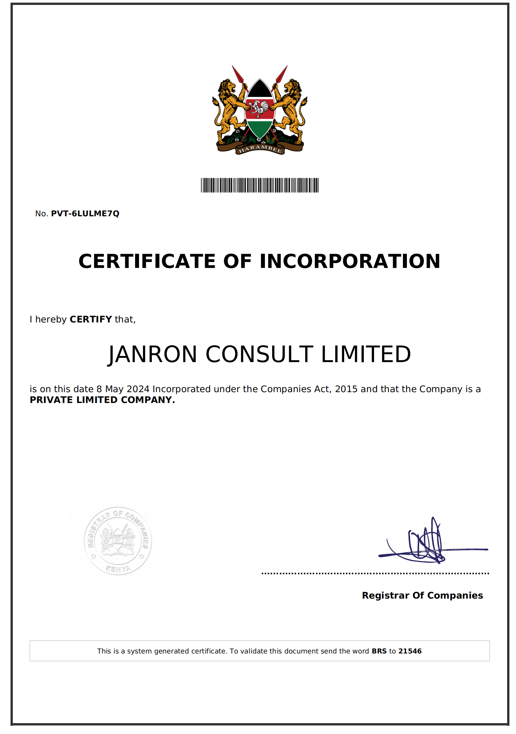

**Company KRA PIN**